Contents

1. Adoptopenjdk 8 INSTALLATION STEPS 2

1. Download link 2

2. Selecting appropriate installer for Windows x64 2

3. Select one of two highlighted options for download 2

4. Java_home variable 3

# Adoptopenjdk 8 INSTALLATION STEPS

## Download link

<https://adoptopenjdk.net/releases.html?variant=openjdk8&jvmVariant=hotspot>

## Selecting appropriate installer for Windows x64

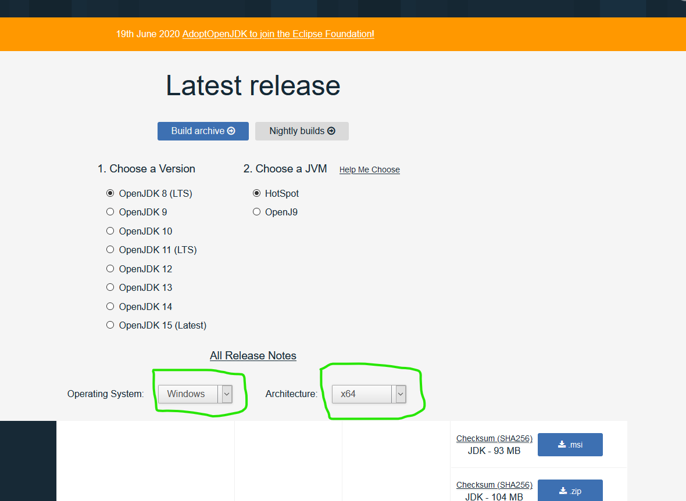

Figure 1 - Selecting windows installer

## Select one of two highlighted options for download

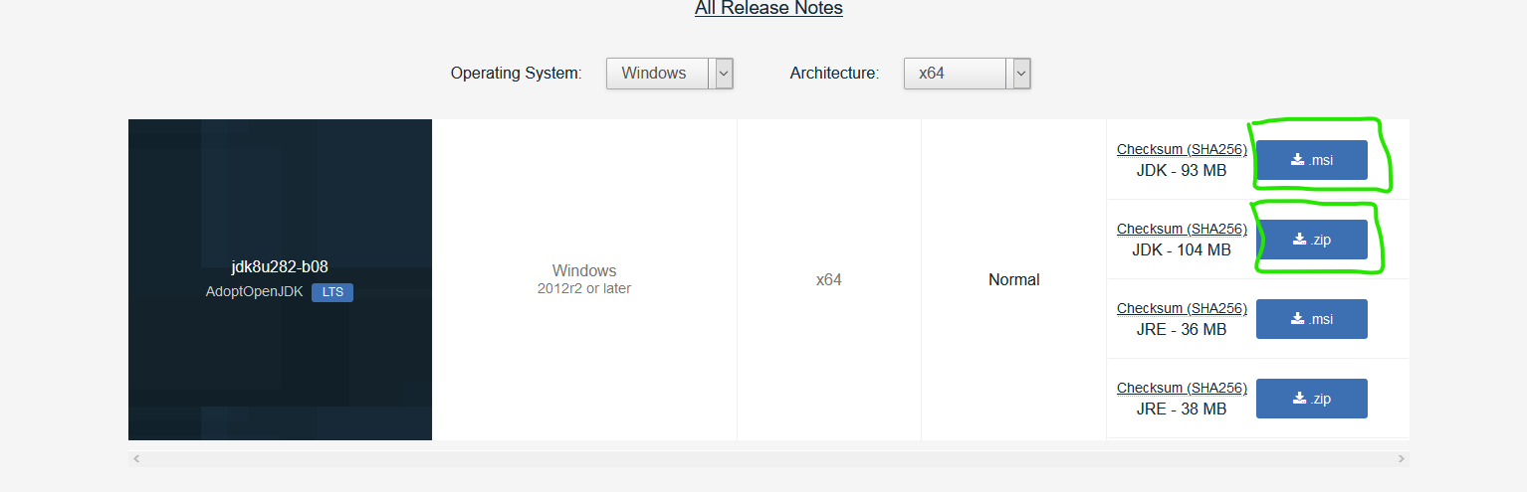

Figure 2 - Download installer

## Java_home variable

Select “Will be installed on local hard drive” option. Click on “Next” and after that on “Finish installation”.

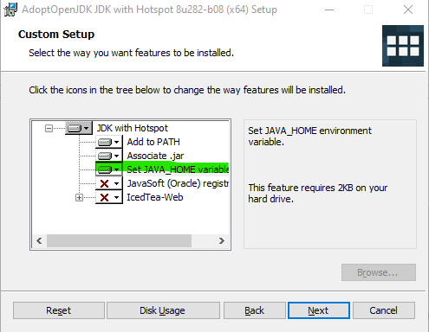

Figure 3 - Java_home variable

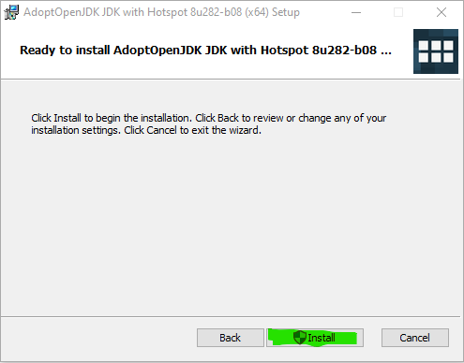

Figure 4 - Finishing installation